**Protocol Status checkmarks screenshots**

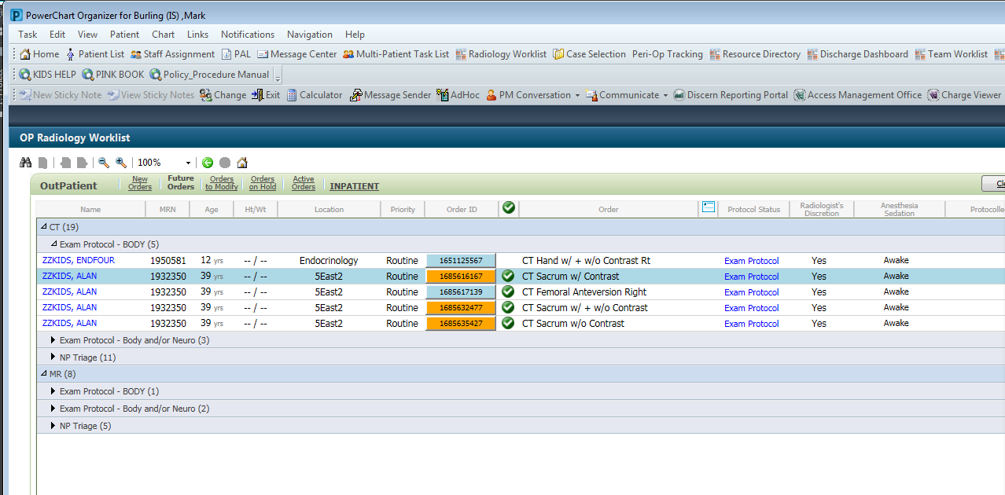

The PROTOSTAT variable is a JS Object {}

Each  “B” + order_id became a unique tag where I stored associated data.

chla.OPRADWL.View.PROTOSTAT = {

                'BOrderId1’ :  “XXXXA”,

                'BOrderId2’ :  “XXXXA”,

                'BOrderId3’ :  “XXXXB”,

                'BOrderId4’ :  “XXXXA”,

                'BOrderId6’ :  “XXXXB”,

               …

                'BOrderId#’ :  “XXXX?”,

}

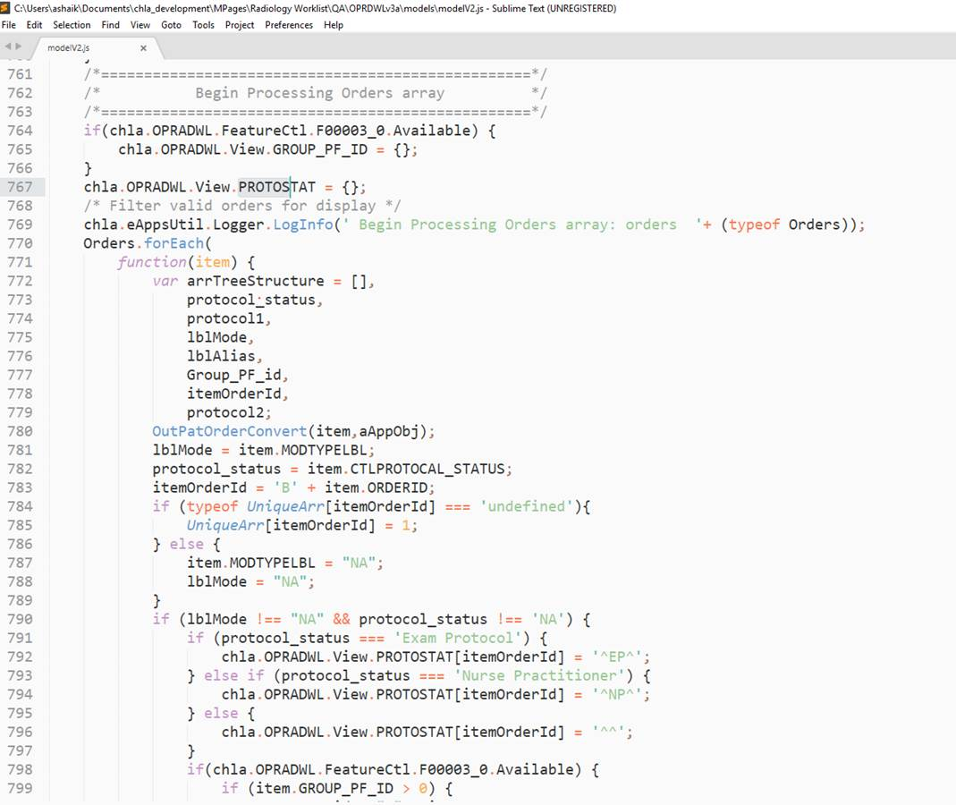

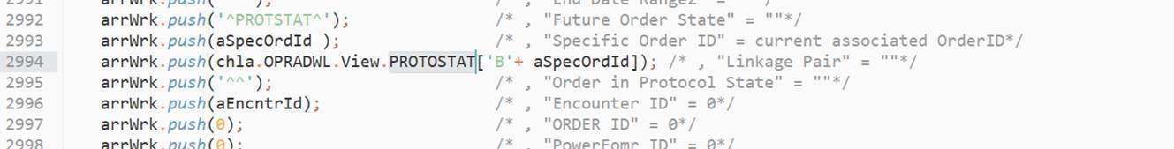

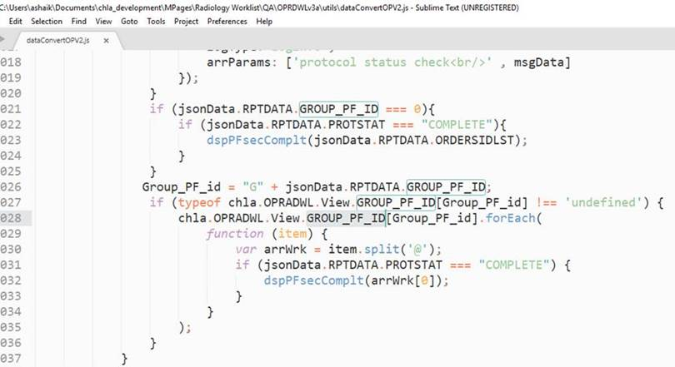

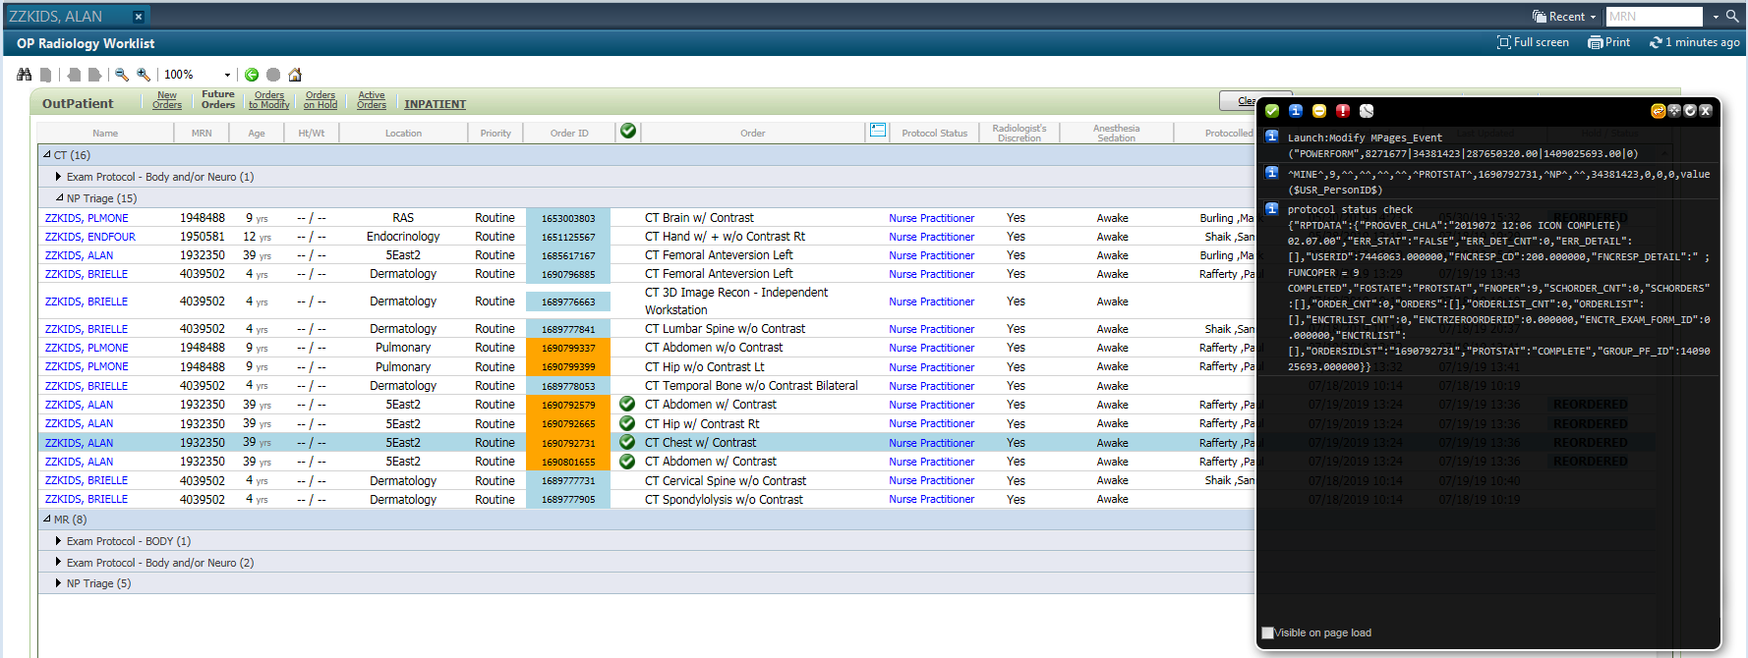

CCL for the “NP” specific “complete” process the grp_pf_id  was not returning a valid value in the CCL response

